National University of Computer and Emerging Sciences

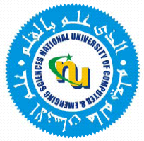

Laboratory Manual # 3

Programming Fundamentals Lab

| Course Instructor | Ms. Arooj Khalil |
| --- | --- |
| Lab Instructor(s) | Ms. Kissa Tanvir  Mr. Zaeem yusuf |
| Section | BCS-1B |
| Semester | Fall 2023 |

**Department of Computer Science**

FAST-NU, Lahore, Pakistan

**Objectives:**

In this lab, students will practice:

1. C++ code
2. Input/output function
3. Condition Operator

**Questions:**

1. Write a program that prints "Welcome to vs code!" to the console.
2. Write a program that takes two integer from user and print that number on the screen.
3. Create a program that asks the user to enter two numbers and then prints their sum.
4. Write a C++ program that asks the user to enter an integer. Check if the entered value is positive. If it's not, display an error message.
5. Write pseudo code that reads two numbers and multiplies them together and print out their product.
6. Write a program that takes a number from user, divide it with 10 and show that result.
7. Write a program that converts a temperature value from Fahrenheit to Celsius. Prompt the user for the temperature in Fahrenheit and display the equivalent temperature in Celsius.
8. Write a program to calculate area of a circle using radius.
9. Write a program that calculate the square of a given number.
10. Write a Program that takes temperatures from user and in it is more than 45° than show alert.